AMENDMENT TO APPLICATION/CONTRACT FOR EXHIBIT SPACE

MANAGED By: SEMI® China
8th Floor, 2nd Building, 1158 Zhangdong Road
Zhangjiang Hi-tech Park, Pudong
Shanghai, China 201203
Tel: 86.21.6027.8500, Fax: 86.21.6027.8511
E-MAIL: semichina@semi.org
SEMICON® China 2022
Shanghai New International Expo Centre
2345 Long Yang Road Pudong New Area
Shanghai, China
March 23-25, 2022

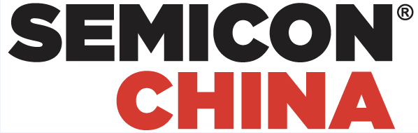

The contract entitled Application / Contract for Exhibit Space for SEMICON China 2022 between SEMI Headquarters and Exhibiting Company:

SEMI Headquarters

[Company Name]

Exhibit Dates in the original contract have been changed from March 16-18, 2022 to March 23-25, 2022.

This Amendment only changes the event date, your company’s booth and exhibition hall will be the same.

These changes are the only changes to the original contract. The entire remainder of the original contract remains in force.

If there is a difference between the English and the Chinese text, the English text shall prevail.

This Amendment shall be signed by the following:

Representative of [Company Name]

Date（日期）:

[Exhibit Primary contact Name]

